# **GITHUB API ACCESS DOCUMENTATION AND UNIT TESTING**

**Objective**: The objective of this document is to inform the concerned user how to use this application in step by step manner.

**Requirement**: As per the user below are the requirements.

* That takes as input: Username, github access token, and the url to a GHE repo
* Using the GHE API ([https://docs.github.com/en/enterprise-server@3.1/rest/reference/repos](https://ind01.safelinks.protection.outlook.com/?url=https%3A%2F%2Fdocs.github.com%2Fen%2Fenterprise-server%403.1%2Frest%2Freference%2Frepos&data=04%7C01%7Cnihar.nanda%40tatasteel.com%7Cadd0e89c09cf413d1f9708d96f933aac%7Cf35425af47554e0cb1bbb3cb9f1c6afd%7C0%7C0%7C637663500411383781%7CUnknown%7CTWFpbGZsb3d8eyJWIjoiMC4wLjAwMDAiLCJQIjoiV2luMzIiLCJBTiI6Ik1haWwiLCJXVCI6Mn0%3D%7C1000&sdata=cYHorByHJkC30ea0jFOumTwO5IHzLImpyBmViITwL5A%3D&reserved=0)) iterate through all the commits for the GHE repo and retrieve each commit comment.
* For each commit comment the program must use a Trie tree to sort the words contained in each commit comment in order based on the ASCII codes for the characters ([https://www.asciitable.com/](https://ind01.safelinks.protection.outlook.com/?url=https%3A%2F%2Fwww.asciitable.com%2F&data=04%7C01%7Cnihar.nanda%40tatasteel.com%7Cadd0e89c09cf413d1f9708d96f933aac%7Cf35425af47554e0cb1bbb3cb9f1c6afd%7C0%7C0%7C637663500411393778%7CUnknown%7CTWFpbGZsb3d8eyJWIjoiMC4wLjAwMDAiLCJQIjoiV2luMzIiLCJBTiI6Ik1haWwiLCJXVCI6Mn0%3D%7C1000&sdata=8xMFVGVm6TWim1HhKBm7oZCJf09HrJ%2Bc0lTaR0A70jA%3D&reserved=0)).
* The program also needs to count the occurrences of each word in the commit comments.
* The program can then output the words in sort order to screen along with the occurrence count for each word.
* The solution should also have the option to export the words as a CSV along with the count of occurrences of each word.

**Technology used**: For this requirement these technologies were used, Asp.net, Web API.

**Steps to use the Application:**

**Step 1:** To open this application concerned user need to open the zip file and run the application in Visual studio. The application will open like this as shared.

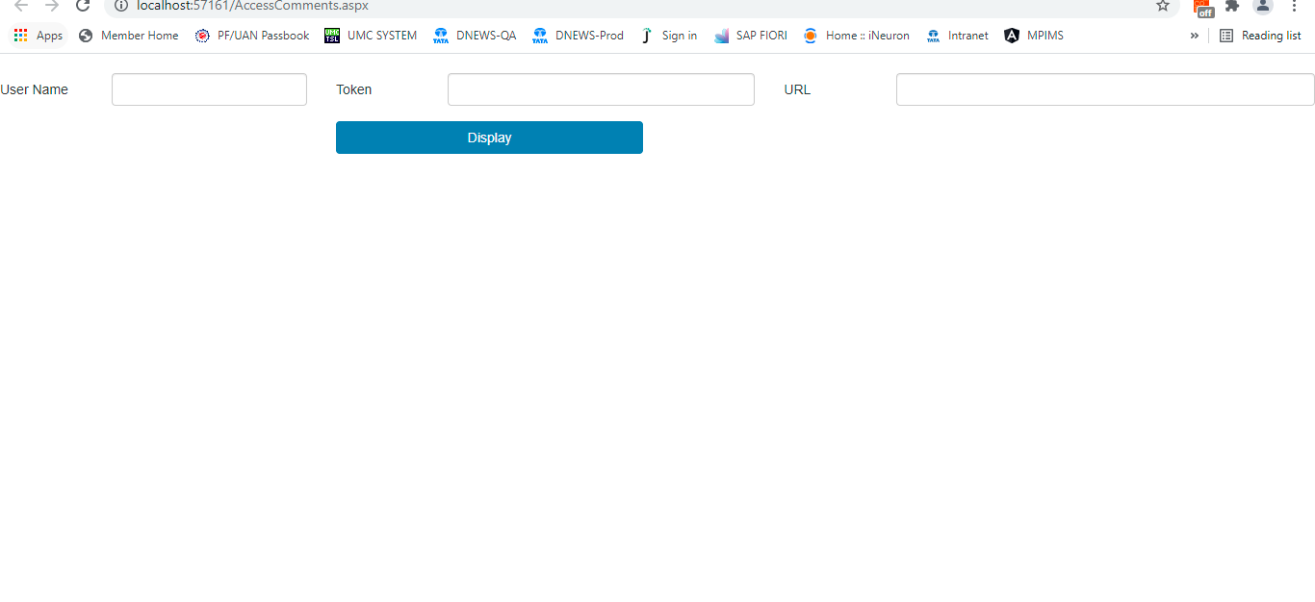

**Step 2:** To access any commit comment of repository user will have to share 2 things at least. If the Repository is private then he will have to generate personal access token by visiting <https://github.com/settings/tokens> or else if the repository is public then he can directly access it only by using API URL. Please note the API URL must be in this format. [https://api.github.com/repos/{username}/{Reposname}](https://api.github.com/repos/%7busername%7d/%7bReposname%7d) ex(<https://api.github.com/repos/nihar139/Test-Projects> )

If wrong URL is entered/ no URL is entered then it will show error.

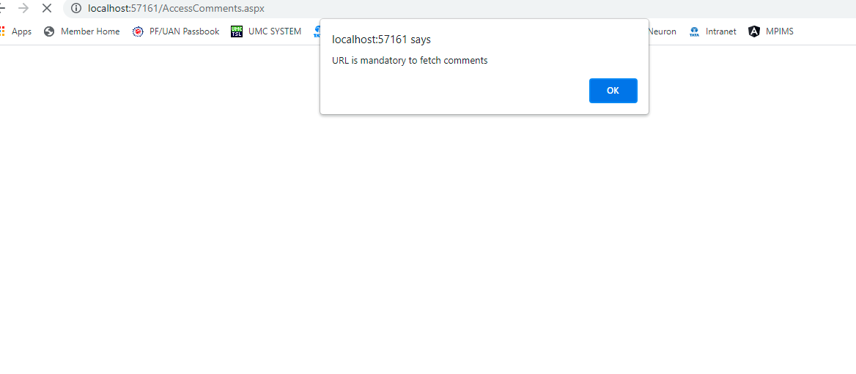

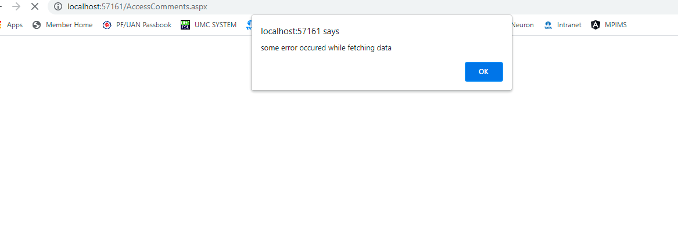

**Step 3:** Once correct URL and Token is entered. On click of Display button user will be able to see all the words present in the commit comment in ASCII order with no of occurrences of those words

Image1: for Private case

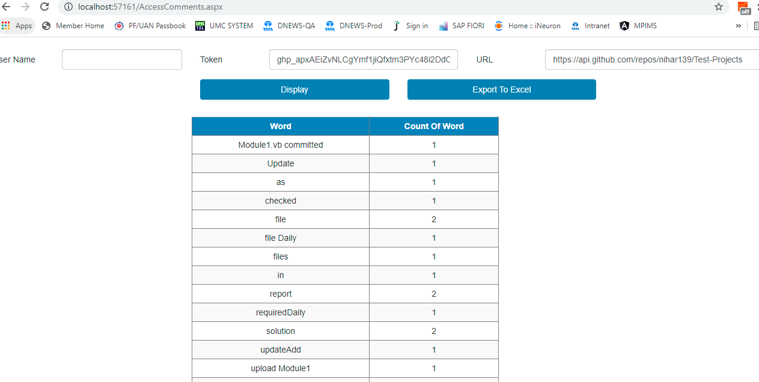

Image 2: For Public case

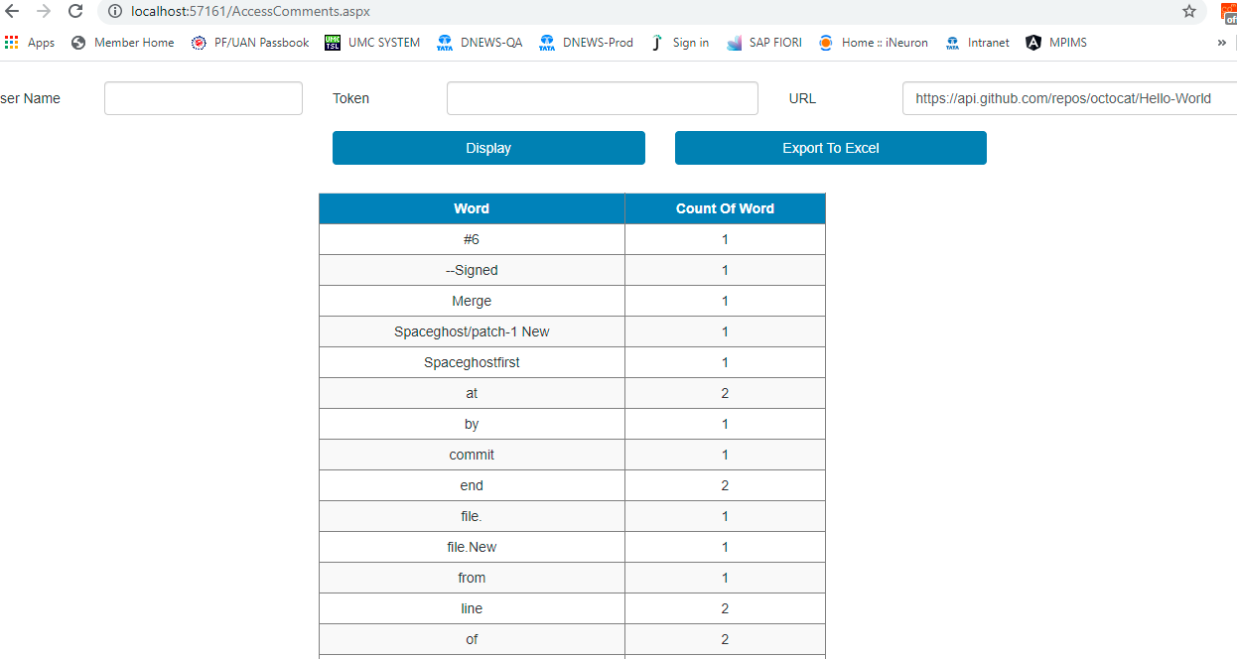

Image 3: Wrong details (Generic error)



**Step 4:** If the user wants to generate excel then he can put correct details and click on Export to Excel button and the details will be downloaded in excel format.

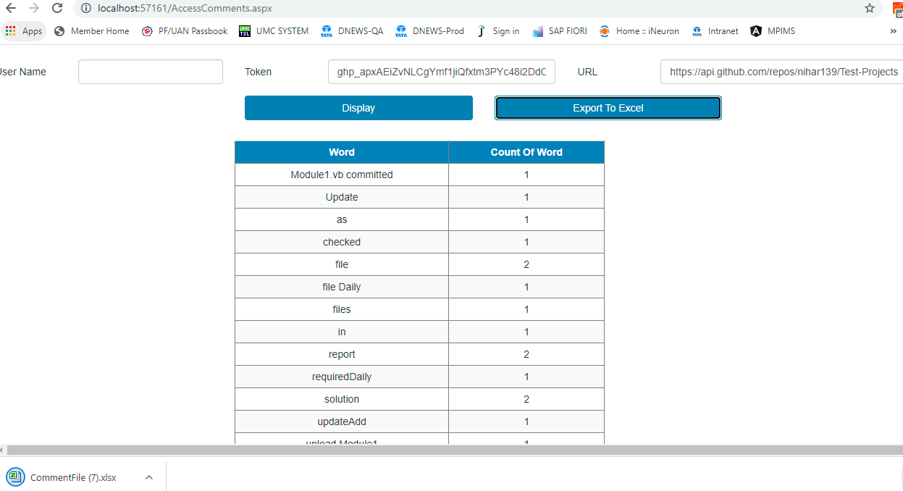

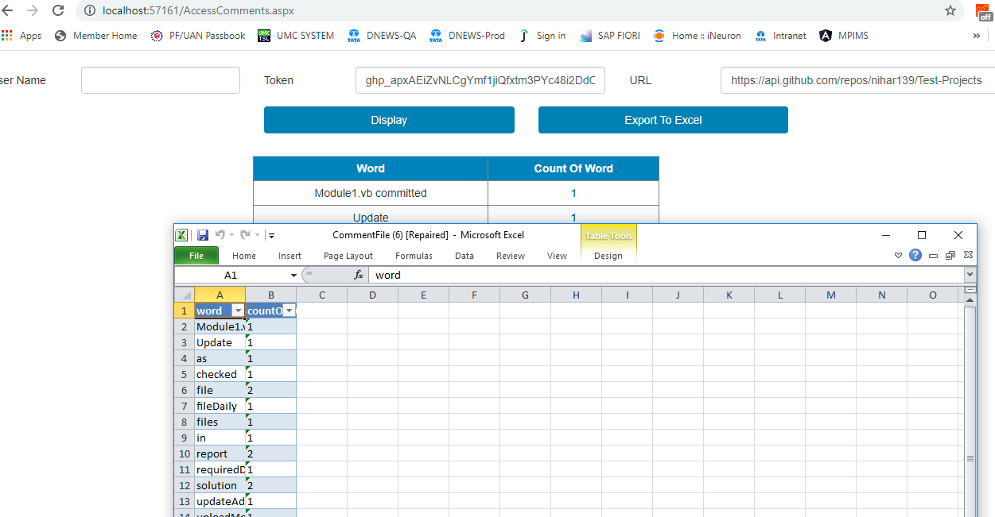

**-----------------------END----------------------**